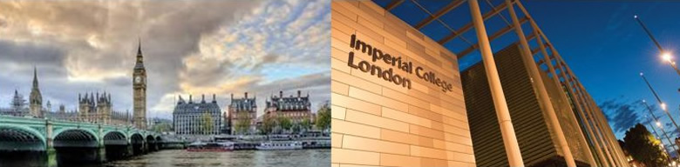

**The 14th International Symposium on Biomechanics in Vascular Biology and Cardiovascular Disease**

**11th-12th April 2019, Imperial College London, UK**

**Organisers**

|  |  |
| --- | --- |
| * **Rob Krams (Chair)** * **Paul Evans** * **Maria Fragiadaki** * **Jovana Serbanovic-Canic** * **Steve White** * **Christina Warboys** | * **Peter Weinberg** * **Jolanda Wentzel** * **Frank Gijsen** * **Kim van der Heiden** * **Hanjoong Jo** * **John Oshinski** |

**Welcome**

**Over the years, the symposium was successful in bridging the gap between biomechanics, vascular biology, and clinical research.**

This year, the scientific program of the symposium will not only cover aspects of vascular biology and clinical research related to biomechanics but will be structured around Controversies in Science. Scientific discussions are the best way to generate new ideas, and we would like to focus on this aspect more strongly. To meet our goal, each session will bring together at least two internationally renowned scientists, each with controversial ideas around the topic. The oral sessions will be complemented with a selection from submitted abstracts. Furthermore, a poster session will be organized and there will be a Young Investigators Award.

Download the abstract book from:

Programme

**Thursday 11th April 2019**

|  |  |  |
| --- | --- | --- |
| **08:00-08:50** | **Coffee, Registration, Poster set-up** | |
| **08:50-09:00** | **Opening: Anthony Bull** | |
| **09:00-09:30** | **Keynote Lecture** | **Chair:  Rob Krams** |
|  | **Yiannis Ventikos**, UCL, London, UK The role of blood flow and inflammation on cerebral aneurysm formation. | |
| **09:30-10:45** | **Cellular mechanosensors** | **Chairs: Hanjoong Jo and J. Serbanovic-Canic** |
| 09:30-09:50 | **Ellie Tzima**, Oxford University, UK The role of PECAM1 in mechano-sensing | |
| 09:50-10:10 | **David Beech**, University of Leeds, UK Piezo-1 and calcium in mechano-sensing | |
| 10:10-10:30 | **Julien Vermot**, IGBMC, France Cilia and their role in mechano-sensing | |
| 10:30-10:45 | **John Tarbell**, New York, USA The role of the mechanosensing endothelial glycocalyx in matrix stiffness-mediated vascular disease | |
| **10:45-11:15** | **Coffee break** | |
| **11:15-13:00** | **Mechano Predictors of Atherosclerosis.** | **Chairs: John Oshinski and Peter Weinberg** |
| 11:15-11:35 | **Ranil de Silva**, Imperial College London, UK Evaluation of shear stress and strain in pig coronaries | |
| 11:35-11:55 | **Peter Stone,** Harvard University, US Spatial relationships among local endothelial shear stress, minimal luminal area, and near-infrared spectroscopy lipid signal in patients with coronary artery disease: *Implications for plaque destabilization* | |
| 11:55-12:15 | **Martin Schwartz,**Yale,Manchester, UK/USA The role of NFkB in mechanotransduction | |
| 12:15-12:30 | **Stephane Avril**, Fr On the role played by wall shear stress in the alteration of biomechanical properties of ascending thoracic aortic aneurysms | |
| 12:30-12:45 | **Eline Hartman**, ErasmusMC, The Netherlands The synergistic effect of NIRS-detected lipid-rich plaque and five different wall shear stress metrics on human coronary plaque growth | |
| 12:45-13:00 | **Blanca Tardajos Ayllón**, Sheffield, UK c-Rel drives atherosclerosis at sites of disturbed blood flow by activating inflammatory and proliferative transcriptional programmes in endothelium. | |
| **13:00-14:30** | **Lunch and Poster Session 1** | |
| **14:30-15:55** | **Imaging of Blood Vessels** | **Chairs: Kim van der Heiden and Ton van der Steen** |
| 14:30-14:50 | **Antoniadis Charalambos**, Oxford University, UK Non-invasive imaging of perivascular fat to predict events. | |
| 14:50-15:10 | **Rene Botnar**, King’s College London, UK Molecular Imaging of advanced plaques. | |
| 15:10-15:25 | **Habib Samedy**, Emory Hospital, Atlanta, USA High Coronary Shear Stress in Patients With Coronary Artery Disease Predicts Myocardial Infarction | |
| 15:25-15:40 | **Yichen Ding**, USA Integrating Light-Sheet Imaging with Advanced Computation to Recapitulate Developmental Cardiac Mechanics | |
| 15:40-15:55 | **Jason Tarkin**, Cambridge, UK Coronary artery inflammation compared to wall shear stress, plaque composition and peri-coronary adipose tissue using PET-CT | |
| **15:55-16:25** | **Coffee break** | |
| **16:25-17:20** | **Gender and Cardiovascular Disease** | **Chairs: Steve White and Jolanda Wentzel** |
| 16:25-16:45 | **Hester den Ruijter**, UMCU, NL Gender differences in CVD- plaque erosion. | |
| 16:45-17:05 | **T Christian Gasser**, KTH Royal Institute of Technology Gender differences in AAA | |
| 17:05-17:20 | **Francoise Lenfant**, Inserm, Toulouse, Fr Gender differences in blood flow-mediated remodeling | |
| **19.30pm** | **Conference Dinner and Drinks -** MK Bar and Grill, 25-35 Gloucester Road, SW7 4PL | |

**Friday 12th April 2019**

|  |  |  |
| --- | --- | --- |
| **08:00-08:50** | **Coffee and Poster Session** | |
| **08:50-09:00** | **Opening: Peter Weinberg** | |
| **09:00-09:30** | **Keynote Lecture 2** | **Chair: Paul Evans** |
|  | **Michael Simons**, Yale, USA TBA | |
| **09:30-10:25** | **Pulse Wave Analysis** | **Chairs: Jordi Alastruey and Frank Gijsen** |
| 09:30-09:50 | **Kim Parker**, Imperial College London, UK Future Directions for Wave Intensity Analysis | |
| 09:50-10:10 | **Peter Weinberg**, Imperial College London, UK A non-invasive method for measurement of arterial wave speed, intensity and refections | |
| 10:10-10:25 | **Sam Vennin**, KCL, UK Ventricular dynamics is a main determinant of the augmentation index: An in in vivo and in silico study | |
| **10:25-11:00** | **Coffee break** | |
| **11:00-12:25** | **What is the cause of plaque destabilization?** | **Chairs: Peter Stone and Christina Warboys** |
| 11:00-11:20 | **Patrick Segers**, University of Ghent, BE Wall shear stress and plaque development: did we buy a pig in a poke | |
| 11:20-11:40 | **Martin Bennet**, Cambridge University, UK  Wall stress is the main determinant of plaque rupture | |
| 11:40-11:55 | **Sandro Satta**, Manchester, UK A pivotal role for Nrf2 in endothelial detachment– implications for endothelial erosion of stenotic plaques | |
| 11:55-12:10 | **Christos Bourantas**, QMUL/UCL, UK Prognostic implications of endothelial shear stress distribution estimated in three-dimensional quantitative coronary angiography models: A combined analysis of the PROSPECT and IBIS 4 studies | |
| 12:10-12:25 | **Ali C. Akyildiz**, ErasmusMC, The Netherlands Mechanical Predictors of Atherosclerotic Plaque Rupture Beyond “Where Stress, There is Rupture” | |
| **12:25-14:00** | **Lunch and Poster Session 2** | |
|  |  | |
| **14:00-15:30** | **Cellular Signaling** | **Chairs: Rob Krams and Maria Fragiadaki** |
| 14:00-14:20 | **Holger Gerhardt**, Max-Delbrück-Center for Molecular Medicine in the Helmholtz Association (MDC), DU Creating and breaking symmetry in vascular networks | |
| 14:20-14:40 | **Thomas Webb**, Leicester, UK JCAD, a human coronary artery disease gene, is a novel regulator of endothelial hippo signaling | |
| 14:40-15:00 | **Paul Evans**, Sheffield University, UK Notch signaling in mechanotransduction | |
| 15:00-15:15 | **Nicole van Engeland**, Eindhoven, the Netherlands Vimentin regulates Notch signaling strength and arterial remodeling in response to hemodynamic forces | |
| 15:15-15:30 | **Christina Warboys**, Imperial College, UK Inflammatory Activation of Endothelial Cells Induced by Disturbed Flow is Regulated by Frizzled-4 and β-catenin via a Non-Canonical Pathway | |
| **15:30-16:00** | **Awards, closing and drinks** | |

Venue information

The symposium will be held at Imperial College London, Exhibition Road, London, SW7 2AZ UK

We will be using the City and Guilds Building marked 28 on the map below.

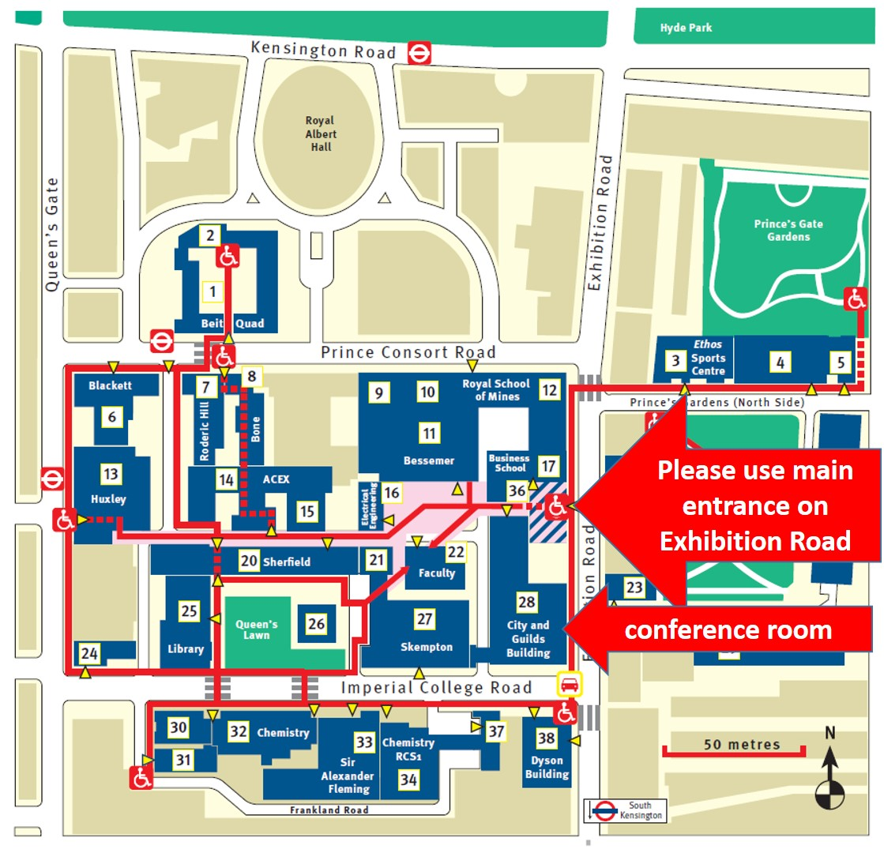

The conference dinner will be at MK Bar and Grill, 25-35 Gloucester Road, SW7 4PL, which is only a 5-10 minute walk form the conference venue.

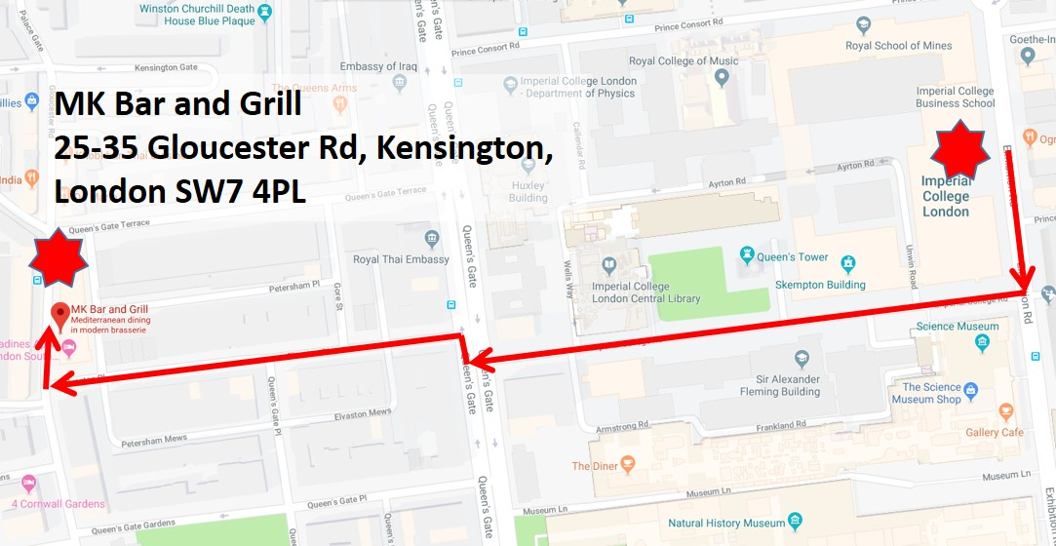

We are extremely grateful for financial support from:













https://www.sems.qmul.ac.uk/content/events/bvbcd2019/images/image001.png



Posters presented on Thursday 11th April

|  |  |  |
| --- | --- | --- |
| 1 | **Synchrotron-based quasi-static pressure inflation of the mouse carotid artery** | Bram Trachet1,2, M. Ferraro2, G. Lovric3, L. Aslanidou2, G. Logghe1, P. Segers1, N. Stergiopulos2 |
| 2 | **Predicting the healthy valve: relationships between the dimensions of the human mitral annulus** | Charlotte Blake1,2, Chirattikan Srisook1,2, Rudolf Billeter-Clark3, Donal McNally2, Ricky Wildman1,Ruth Goodridge1 |
| 3 | **On the Use of Circulating Osteogenic Blood Biomarkers to Determine Atherosclerotic Calcification Phenotype** | Rachel Cahalane1, Hilary Barrett1,2, Aisling Ross1, John Mulvihill1, Helen Purtil3, Julie O’Brien4, Eamon Kavanagh5, Michael Moloney5, Michael Walsh1 and Eibhlis O’Connor6 |
| 4 | **Computational Fluid Dynamics to predict thrombosis of a stentgraft inserted for peripheral artery occlusive disease** | Lennart van de Velde, Erik Groot Jebbink, Michel Versluis, Michel Reijnen |
| 5 | **A novel method for more representative vessel model reconstruction and assessment of the local hemodynamic forces in coronary artery segments with metallic stent** | Ryo Torii1, Anantharaman Ramasamy2, 3, Chongying Jin2, 3, Hannah Safi2, 3, Thomas Zanchin2, 6, Daniel Jones2, 3, Pieter Kitslaar4, Jouke Dijkstra4, Yoshinobu Onuma5, Lorenz Raber6, Muhiddin Ozkor2, Rob Krams3, Anthony Mathur2, 3, Patrick W. Serruys7, Andreas Baumbach2, Christos V. Bourantas1 |
| 6 | **High-resolution mapping of flow dynamics in the zebrafish cardiovascular system** | Jonathan M. Taylor1, Vytautas Zickus1 |
| 7 | **Patient-specific Assessment of Stroke Risk in Pediatric Cerebrovascular Disease** | Shaolie S. Hossain1,2, Zbigniew Starosolski3, Travis Sanders1, Dianna Milewicz4, and Ananth Annapragada3 |
| 8 | **An animal-specific study investigating the association between helical flow and atherosclerotic plaque progression in coronary arteries** | Giuseppe De Nisco, Ayla Hoogendoorn, Annette Kok, Claudio Chiastra, Diego Gallo, Jolanda Wentzel, Umberto Morbiducci |
| 9 | **Ultrasound-image-based assessment of shear strain of the carotid artery in an intensive care unit** | Spyretta Golemati1, Demosthenes D. Cokkinos2, Spyros Zakynthinos1 |
| 10 | ***In vivo* function of flow-responsive *cis*-DNA elements in the endothelial nitric oxide synthase gene: a role for chromatin-based mechanisms** | Kyung Ha (Kay) Ku1,2, Britta J. Knight1, Philip A. Marsden1 |
| 11 | **Mechanosensitive Piezo1 channels mediate insulin release from pancreatic b-cells** | Vijayalakshmi Deivasikamani1, Savitha Dhayalan1, Romana Mughal1, Asjad Visnagri1, Kevin Cuthbertson2, Jason L Scragg1, Nicola Blythe1, Tim S Munsey3, Hema Viswambharan1, Richard Foster2, Asipu Sivaprasadarao3, Mark T Kearney1, David J Beech1 & Piruthivi Sukumar1 |
| 12 | **Coronary Stent Fracture: Biological Consequence & Lifetime Prediction** | Claire Conway1,2, Elazer Edelman2 |
| 13 | **Substrate Regulation of Vascular Endothelial Cell Shape and Alignment** | Abdul I. Barakat1,2, Carlo Natale1, Maria Gusseva1, Julie Lafaurie-Janvore1, Avin Babataheri1 |
| 14 | **Intracranial aneurysm under high frequencies: can turbulent-like hemodynamic conditions translate to characteristic wall vibrations?** | Alban Souche, Kristian Valen-Sendstad |
| 15 | **An assessment of methods to estimate cardiovascular parameters from blood pressure and flow waveforms** | Jorge Mariscal-Harana1, Peter H Charlton1, Spencer Sherwin2, Jordi Alastruey1 |
| 16 | **Piezo1 channel coupling to endothelial nitric oxide synthase** | Hannah J Gaunt1, Marjolaine Debant1, Melanie J Ludlow1, Fiona Bartoli1, David J Beech1 |
| 17 | **Patient-specific hemodynamic analysis of CT-derived stented superficial femoral arteries** | Monika Colombo1, Marco Bologna2, Marc Garbey3,4, Scott Berceli5,6, Yong He6, Josè Felix Rodriguez Matas1, Francesco Migliavacca1, Claudio Chiastra1,7 |
| 18 | **Numerical Investigation on the effect of Blood pressure on Wall Shear Stress and Vorticity.** | Nitesh Kumar1,2, Raghuvir Pai B1, P A Kyriacou2,S M Abdul Khader1,S H Khan2 |
| 19 | **Development and Testing of An Ultrasound Compatible Cardiac Phantom For Interventional Procedure Simulation Using Direct 3d Printing** | Shu Wang, Yohan Noh, Jemma Brown, Shuangyi Wang, Richard Housden, Mar Casajuana Ester, Ronak Rajani, and Kawal Rhode |
| 20 | **Determinants of Peripheral Pulse Pressure and Pulse Pressure Amplification** | Ye Li, Antoine Guilcher, Samuel Venin, Peter Chalton, Jordi Alastruey, Phil Chowienczyk |
| 21 | **Nitric Oxide Regulates Human Erythrocyte Deformability through regulating Band 3 Phosphorylation Status in Hypoxia** | Yajin Zhao, Man Hou, Qinqin Yang, Xiang Wang* |
| 22 | **Primary cilia affect the endothelial response to aneurysmal wall shear stress** | Mannekomba R Diagbouga1, Sandrine Morel1, Beerend Hierck2, Sylvain Lemeille1, Brenda R Kwak1 |
| 23 | **A Novel Method to Predict Risk in Coronary Artery Bypass Graft Patients** | Arron Peace12 Andrew Muir3 Robyn Lotto1 Ian Jones1 Dick Thijssen2 |
| 24 | **RGD-functionalized superparamagnetic γ-Fe2O3 nanoparticles enhance the cell migration of osteoblasts *in vitro*** | LIU Xue#, YANG Xiao-ling#, HU Qiao, LIU Mao-shi, XU Wen-feng, HUANG Qiu-hong, LIAO Xiao-ling* |
| 25 | **Gender differences in the resolution of intraluminal thrombosis in a rat aneurysm model** | Sandrine Morel1,2, Agnieszka Karol3, Vanessa Graf3, Graziano Pelli1, Henning Richter4, Esther Sutter1, Vincent Braunersreuther1, Juhana Frösen5, Philippe Bijlenga2, Brenda R. Kwak1, Katja M. Nuss3 |
| 26 | **Modeling of Vascular Delivery of Targeted Nanoparticles to Detect Vulnerable Plaques** | Shaolie S. Hossain, Thomas J.R. Hughes |
| 27 | **Developing an indicator of rupture in abdominal aortic aneurysm using XFEM approach** | Wisam Al-obaidi1,3, Alistair Revell1, Christopher Lowe2, Parthasarathi Mandal1 |
| 28 | **Spatially Resolved Distensibility of Healthy, Diseased, and Aneurysmal Aortic Walls Determined from Temporally Resolved 3D Ultrasound Measurements** | Andreas Wittek1, Wojciech Derwich2, Thomas Schmitz-Rixen2, Armin Huß1, Christopher Blase1 |
| 29 | **Quantifying orientation of endothelial cells under uniaxial and multidirectional flow by swirling normal and modified cell culture plates with and without raised viscosity of the medium** | Mehwish Arshad1,2, Mean Ghim1, Spencer J. Sherwin2 and Peter D. Weinberg1 |
| 30 | **Comparison Between Invasive and Non-invasive Wave Intensity Analysis Using 1D Computational Modelling of Arterial Haemodynamics** | Ryan Reavette1, Mengxing Tang1, Spencer Sherwin2, Peter Weinberg1 |
| 31 | **A systematic investigation into the measurement of skin microcirculation in the foot** | Gayathri Balasubramanian, Nachiappan Chockalingam, Roozbeh Naemi |
| 32 | **Suppression of endothelial activation depends on the type and duration of applied shear stress in vitro** | Kuin Tian Pang1,2, Mean Ghim1, Xiaomeng Wang2,3,4,5, Peter D. Weinberg1 |
| 33 | **Can turbulent-like flow cause high frequency vibrations of intracranial aneurysm walls?** | Alban Souche, Kristian Valen-Sendstad |
| 34 | **Should aortic dilated bicuspid aortic valve patients be treated like other aneurysms?** | Ya Hua Chim1, Hannah Davies2, Mark Field3, Jill Madine2, Riaz Akhtar1 |
| 35 | **Imaging of blood flow dynamics using engineered point-spread functions** | Yongzhuang Zhou, Vytautas Zickus, Jonathan M. Taylor, Andrew R. Harvey |
| 36 | **Distal Pressure Measurement Location and Its Impact on Virtual Fractional Flow Reserve** | Eric KW Poon1, Shuang J Zhu1, Andrew SH Ooi1, Peter Barlis2 |
| 37 | **The mechanical properties of the ovine aorta at the macro- and micro- scale correlation with regional variations in collagen, elastin and glycosominoglycan levels** | Phakakorn Panpho1,4, Mark Field2, Jillian Madine3, Riaz Akhtar1 |
| 38 | **FSI modeling of an atherosclerotic murine carotid artery instrumented with a blood flow-modifying cuff!** | Miten B. Patel1, Fotios Savvopoulos1, Ranil de Silva1,4, Ryan M. Pedrigi2, Rob Krams3 |
| 39 | **An *in vitro* tissue-based model of vascular remodeling in the descending aorta at intercostal artery branch points** | Mairi E. Sandison |
| 40 | **Manipulation of angiogenesis: controlling sprouting with patterns of notch ligands** | Laura Tiemeijer1,2, JP Frimat3, Oscar Stassen2, Carlijn Bouten2, Cecilia Sahlgren |
| 41 | **Piezo1 ion channels are required for shear stress sensing in placental blood vessels** | 1,2Lara Morley, 1Sara Ibrahem, 1Jian Shi, 1Hannah Gaunt, 2James Walker, 2Nigel Simpson, 2David Beech |
| 42 | **Atorvastatin effect on homing of MSCs and EPCs on a 3D blood vessel model** | Njoroge W1, Harper A1, Butler R1,2, Sandhu K2, Yang Y1 |
| 43 | **Anthropomorphic Cardiac Valve Fabrication Based on Two-part Water Soluble PVA Mould** | Shu Wang*, Harminder Gill*, Yohan Noh, Nio Amanda, Joao Filipe Fernandes, Ronak Rajani, Pablo Lamata, and Kawal Rhode |
| 44 | **Developing new machine learning tools to interrogate the epigenome of endothelial cells during plaque development in vivo** | Yean Kok Chooi2, Roza Nikolopoulou2, C.A. Mein3, Eva Wozniak3, Alex Delahunty2, Nasar Jarka1,2, Miten B. Patel1,2, Fotios Savvopoulos1,2, Pan Jang1,2, Ranil de Silva1, and Rob Krams2 |
| 45 | **Exploring the interaction between age, sex and differing types of exercise upon exercise-induced shear stress and subsequent markers of vascular health** | Gemma K. Lyall, Karen E. Porter, Karen M. Birch |
| 66 | **GenEPi: Piezo1-based fluorescent reporter for visualizing mechanical stimuli with high spatiotemporal resolution** | Sine Yaganoglu1, Nordine Helassa2,3, Benjamin M. Gaub1, Maaike Welling1,4, Jian Shi5, Daniel J. Müller1, Katalin Török2, Periklis Pantazis1 |

Posters presented on Friday 12th April

|  |  |  |
| --- | --- | --- |
| 46 | **The influence of bending on coronary arteries bio-mechanics assessed by fluid-structure interaction modelling** | Pan Yang1, Naser Jarka1, Miten Patel1, Fotios Savvopoulos1, Ryan M. Pedrigi2, Rob Krams3, Ranil de Silva1 |
| 47 | **Cuffless BP Estimation Using Single Channel PPG: Evaluation of Machine Learning Approaches on MIMIC II database** | Syed Ghufran Khalid, Jufen Zheng, Dingchang Zhang |
| 48 | **A numerical analysis of the stress distributions in an idealised, three-dimensional model of an atherosclerotic plaque** | César Alegre Martínez, Kwing-So Choi, Outi Tammisola, Donal McNally |
| 49 | **Stabilisation of Vessel Bifurcations during Flow-Regulated Vascular Remodelling** | Lowell T. Edgar, Miguel O. Bernabeu |
| 50 | **Effect of Patient-Specific Values of Coronary Flow Reserve (CFR) on the Accuracy of Non-Invasive Fractional Flow Reserve (FFR) Estimates** | John Oshinski (1,2), Jackson Hair (2), David Molony (3), Lucas Timmins (4), Habib Samady (3) |
| 51 | **Manipulating shear rate patterns in the common femoral artery using acute continuous and interval exercise** | Abigail L. Cook (1), Gemma K. Lyall (1), Paul C. Evans (2), Karen M. Birch (1) |
| 52 | **Shear-induced maturation of human pluripotent stem cell-derived endothelial cells towards an arterial subtype[1]** | Jing Ying Adele Lam1,2­­, Seep Arora1,3, Christine Cheung6,7, Evelyn KF Yim8, Yi-Chin Toh |
| 53 | **A numerical study of smooth muscle cell sensitivity in vascular remodeling** | Lauranne Maes1, Julie Vastmans1, Stéphane Avril2, Nele Famaey1 |
| 54 | **Multidirectional wall shear stress promotes development of coronary plaques with vulnerable characteristics – a pre-clinical imaging and histopathological study** | Ayla Hoogendoorn1, Annette M. Kok1, Eline M.J. Hartman1, Claudio Chiastra2, Lorena Casadonte3, Adriaan Coenen1, Suze-Anne Korteland1, Kim van der Heiden1, Frank J. H. Gijsen1, Dirk J. Duncker1, Antonius F.W. van der Steen1, Jolanda J. Wentzel1 |
| 55 | **Endothelial Sox17 is critical for maintaining adult artery phenotype and enhances arterial response to hemodynamic flow** | Diana Kim, Guohao Dai |
| 56 | **Increasing Membrane Tension Transiently Reduces Syndecan-1 Expression through Actin Remodelling** | Weiqi Li and Wen Wang |
| 57 | **Uniaxially sheared endothelial cells secrete mediators that reduce inflammation and endothelial permeability** | Mean Ghim, Kuin T Pang, Peter D Weinberg |
| 58 | **Towards the Establishment of Lesion-specific Stenting Strategies: Correction of Curvature Induced OCT Image Distortion is Required for Accurate 3D Reconstructions of Deployed Coronary Stents** | Mark R. Elliott1, David S. Molony2, Brigham R. Smith3, Sarang Joshi1,4, Habib Samady2, Lucas H. Timmins1,4 |
| 59 | **A Novel Approach for Heterogenous Material Characterization of Atherosclerotic Plaques** | Ronald D. van den Berg1, Stephane Avril2, Frank J.H. Gijsen1, Ali C. Akyildiz1 |
| 60 | **High LDL filtration rate and plaque development in intracranial arteries: a computational study** | Haipeng Liu1,2, Dingchang Zheng1, Xinyi Leng2, Linfang Lan2, Hing Lung Ip2, Thomas Wai Hong Leung2 |
| 61 | **Effect of Calcification & Fibrous Tissue Features on Atherosclerotic Plaque Rupture Risk** | Bas Vis, Hilary Barrett, Astrid Moerman, Frank J.H. Gijsen, Ali C. Akyildiz |
| 62 | **Impaired ALK1 mechanotransduction and inflammation converge on Connexin37 (Cx37) to permits high-flow arteriovenous shunting** | Hanna M Peacock 1, Nathan Criem 1, Ashkan Tabibian1 Vincenza Caolo 2, Lauriane Hamard 3, Jacques-Antoine Haefliger 3, Brenda R Kwak 4, An Zwijsen 1, Elizabeth AV Jones |
| 63 | **An MRI-based pipeline to register patient-specific wall shear stress data to histology** | Astrid M. Moerman, Kristine Dilba, Suze-Anne Korteland, Dirk H.J. Poot, Stefan Klein, Jolanda J. Wentzel, Kim van Gaalen, Ellen V. Rouwet, Aad van der Lugt, Antonius F.W. van der Steen, Frank J.H. Gijsen and Kim van der Heiden |
| 64 | **The effect of confounding factors on flow mediated dilation: a novel computational study using one-dimentioanal blood flow modelling** | Weiwei Jin1, Phil Chowienczyk2, Jordi Alastruey1 |
| 65 | **Flow-dependent regulation of caspase-3 in endothelial cells** | Virginia Tajadura*, Marie Haugsten-Hansen*, Vasco Claro*, Julian Evans*, Christina Warboys± and Albert Ferro* |
| 67 | **Hemodynamics in the HeartMate 3 under dynamic operating conditions: Of the need to understand the biologic effects of turbulence on blood** | Lena Wiegmann1, Bente Thamsen2, Diane de Zélicourt1, Marcus Granegger2,3, Stefan Boës4, Marianne Schmid Daners4, Mirko Meboldt4, Vartan Kurtcuoglu1 |
| 68 | **Flow-responsive Notch signaling modulates EFNB2/EphB4 Axis to promote vascular regeneration** | Kyung In Baek1, Meyrdad Roustaei1, Chih-Chiang Chang1, Shyr-shea Chang2, Marcus Roper2, Rongsong Li3, Tzung K. Hsiai1.4 |
| 69 | **Ex Vivo Organotypic Model for the Study of the Epicardium** | Davide Maselli, Patrizia Camelliti, Robert D Johnson, Rolando S Matos, Ciro Chiappini, Paola Campagnolo |
| 70 | **Vascular constructs using human pluripotent stem cells in the therapy of peripheral arterial disease** | Eleonora Zucchelli1, Qasim Majid1, Thomas J Owen1, Edit Gara2, Sian Harding1, Gábor Földes1 |
| 71 | **Systematic evaluation of the influence of wall shear stress features on endothelial cell phenotypes in-vitro with correlation to ex-vivo bovine Arteriovenous tissue** | David T. O’Connor, Marco Franzoni, Michael T. Walsh |
| 72 | **A Novel High-throughput loss-of-fundtion Microarray Platform for Targeting Gene Networks in Primary Cells** | Aliah Abuammah 2, 3, 4, Nataly Maimari 1, Sean Herault 1, Jacques Behmoaras 2, Rob Krams 3, Christina Warboys 1 and Leila Towhidi |
| 73 | **Piezo1 channels are expressed and functional in cardiac fibroblasts** | Nicola M Blythe, Mark J. Drinkhill, David J. Beech, Neil A. Turner |
| 74 | **Contractile and Hemodynamic Forces Promote Cardiac Valve Development via Notch1b-mediated Endothelial-to-Mesenchymal Transition** | Jeffrey J. Hsu1, Vijay Vedula2, Kyung In Baek3, Cynthia Chen3, Junjie Chen3, Man In Chou3, Jeffrey Lam3, Shivani Subhedar3, Jennifer Wang3, Yichen Ding3, Chih-Chiang Chang3, Juhyun Lee4, Linda L. Demer1,3,5, Yin Tintut1,5, Alison L. Marsden2, Tzung K. Hsiai1,3 |
| 75 | **The Impact of Strut Design on the Hemodynamic Behaviour of Various Bioresorbable Scaffolds** | Imane Tarrahi1, Eline Hartman1, Monika Colombo2, Claudio Chiastra2,3, Ryo Torii1, Natalia Tovar1, Jolanda Wentzel1, Joost Daemen1, Frank Gijsen1 |
| 76 | **Imaging the Depostion of Nanocarriers in Patient Reconstructed Blood Vessels** | Maria Khoury, Mark Epshtein and Netanel Korin |
| 77 | **Contribution of endothelial Piezo1 channels to whole body physical activity** | Fiona Bartoli1, Lee D Roberts1, T Simon Futers1, David J Beech1 |
| 79 | **A Microfluidic Model of Ischemia/Reperfusion Injury** | Danielle Nemcovsky Amar and Netanel Korin |
| 80 | **The Influence of Mechanical Factors on Occludin Expression of HUVECs** | Junyang Huang, Shuang Ge, Desha Luo, Yang Wang, Ruolin Du, Tieying Yin, Guixue Wang |
| 81 | **Changes in tight junction-associated proteins after PLLA stent implantation** | Shuang Ge, Yang Wang, Ruolin Du, Junyang Huang, Tieying Yin*, Yazhou Wang, Guixue Wang |
| 82 | **Endothelial Tight Junction Protein Zo-1 Response to Multiple-Mechanical Stimulations** | Yang Wang, Shuang Ge, Desha Luo, Ruolin Du, Yazhou Wang, and Guixue Wang |
| 83 | **Local Disturbing Flow Induced by Stent Implantation Affects Endothelial Cell Rearrangement and Endothelialization** | Ruolin Du, Yuzhen Ren, Shicheng He, Shuang Ge, Yang Wang, Junyang Huang, Yazhou Wang, Guixue Wang, Tieying Yin* |
| 84 | **Predicting False Lumen Thrombosis after TEVAR in Type B Aortic Dissection** | C.H. Armour [1] ^, C. Menichini [1] ^, K. Milinis [2], R.G.J. Gibbs [3], X.Y. Xu [1] |
| 85 | **Mechanical Regulation of Autonomously Forming Endothelial Gaps and Cancer Extravasation** | Jorge Escribano1,2, Michelle B. Chen2,3, Emad Moeendarbary2,4, Xuan Cao5, Vivek Shenoy5, Jose Manuel Garcia-Aznar1,*, Roger D. Kamm2,6,7,*, Fabian Spill6,8,* |
| 86 | **Endothelial Stat5a is enriched at atheroprone regions of the aorta and drives inflammation in response to low shear stress** | Hannah Roddie, Maria Fragiadaki* and Paul Evans* |
| 87 | **Disturbed flow induces aortic valve calcification by activating the HIF-1α Pathway triggered by loss of miR-483-3p, leading to increased UBE2C and degradation of pVHL** | Joan Fernandez Esmerats1, Nicolas Villa-Roel1, Sandeep Kumar1, Lina Gu1, Md Tausif Salim2, Michael Ohh3, W. Robert Taylor4, Robert M. Nerem5, Ajit P. Yoganathan1,2, and Hanjoong Jo1,2 |
| 88 | **4D Ultrasound of Murine Abdominal Aortic Aneurysms** | Hannah L. Cebull1, Daniel J. Romary1, Craig J. Goergen1 |